

Do you want to go to college?

Our program assists students in **middle school/junior high and high school** in planning and preparing for their futures setting them up to achieve their goals. No Cost Federally Funded Program

WE CAN HELP YOU!

* Fun activities
* FREE trips to college & career sites
* FREE tutoring
* Prepare for high school and college
* Help completing college, scholarship, and other financial aid applications
* SAT/ACT prep courses
* Parent workshops
* Leadership opportunities

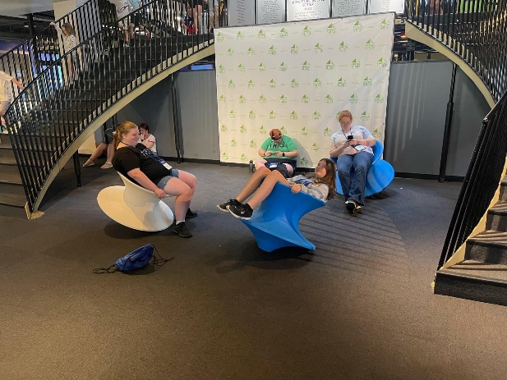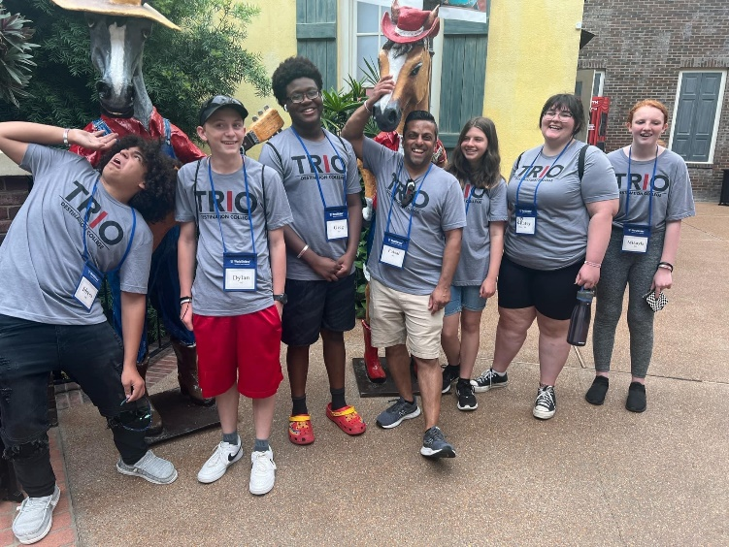

**CONTACT US TODAY!**

**217-234-5456**

**5001 Lake Land Blvd. Mattoon, IL 61938**

**You can also apply online!**

Scan the QR code or go to https://www.lakelandcollege.edu/triodc

**Become a**

**TRIO DC Achiever Today!**

**Please complete all information below. Incomplete applications will delay processing.**

|  |  |  |  |
| --- | --- | --- | --- |
|  |  | |  |
| **TRIO Destination College Student Application** | |

Date of Application: / / Current Grade: School: ____________________________

Month Day Year

Name: _________________________________________________________________________________________

Last Name First Name Middle Initial Preferred Name

Mailing Address: _________________________________________________________________________________

Street Name & Number PO BOX City State Zip Code

Student Cell: ( ) __________ Please check this box if you do **NOT** want TRIO Destination College to text you.

Student’s E-mail Address: _______________________________________________

Date of Birth: / / Age: ______ Gender: M __ F__

Month Day Year

Are you a citizen/Permanent Resident of the United States? __Yes __No

Ethnic Background: __Hispanic/Latino __White __Native American __Pacific Islander

__African- American __Asian __Multiracial

**HOUSEHOLD INFORMATION**

Student lives with: __Natural Parents __Natural Parent & Step-parent __Single Parent

__Legal Guardian/Foster Parent __Other _____________________________

Parent/Guardian Information: ______________________________________________________________

Last Name First Name Relationship

Parent Phone: (___) __________ Please check this box if you do **NOT** want TRIO Destination College to text you.

Do you have another child currently participating in the TRIO Destination College? Yes__ No__

If yes, please provide child’s name and school currently attending: _______________________________

We would love to reach out to any sibling or friend in middle school/junior high or high school **NOT YET** in the program, please list them:

|  |  |  |  |
| --- | --- | --- | --- |
| Print Name(s) of Student | Grade | School | Relationship |
|  |  |  |  |
|  |  |  |  |
|  |  |  |  |

**EDUCATION & INCOME VERIFICATION**

Lake Land College Destination College, a Talent Search project, is required by the *US Department of Education* to verify educational background and household income level for all participants. (34CFR643.10) All information will be held in strict confidence, and we will adhere to the Family Educational Rights and Privacy Act of 1974 (FERPA).

Taxable Income is usually lower than the Total or Gross Income. Please call 217-234-5003 or 217-234-5048 if you have any questions or need assistance locating this information. If possible, please include a copy of your tax form with application. 34CFR643.7

1. Did either of the applicant’s parents, who live with the applicant, earn a baccalaureate degree (4-year degree) or Higher? __Yes __No (Please do not answer for natural parents who do not live with the applicant, stepparents, grandparents or legal guardians)

2. **My household’s Annual Taxable Income (after deductions) for the previous year was:** _________________

**Or** I have no taxable income and am not required to file a tax return. ­­­­­

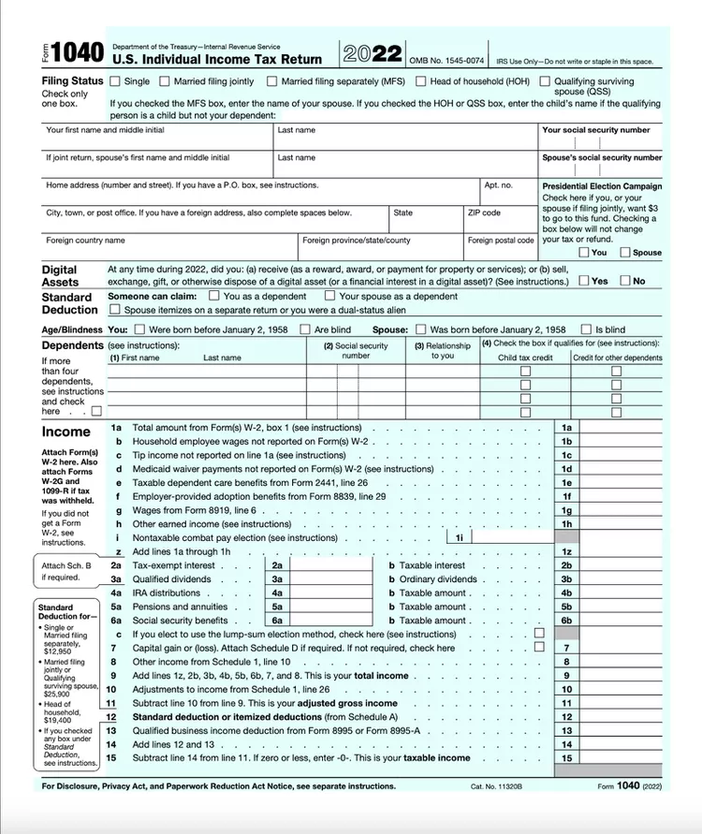

3. Please provide the number in your household. Include yourself and anyone supported by your income. _______

4. Is the applicant in foster care and/or ward of the state of Illinois? __Yes __No

**RELEASE STATEMENT & AGREEMENT**

Please read carefully and sign where indicated. Failure to provide a signature will delay processing of the application.

* I certify that the information provided is true and accurate to the best of my knowledge
* I hereby authorize the release of all secondary & post-secondary school records to the Destination College program.
* I authorize Destination College to share and discuss any information with my parents or legal guardians.
* I understand that all information on this application as well as that released from the school will be held in strict confidence by Destination College.
* I give permission to Destination College to take photographs during activities, trips, events and to use my child’s name and/or photo for Destination College educational and/or promotional purposes. *
* Our signatures below indicate our commitment to our child’s education and Destination College.
* I understand TRIO Destination College may contact me or my child by phone call, text, in person or virtually online.

I understand that this authorization remains in effect while a participant in Destination College and through post-secondary education.

I will provide Destination College with written notice to revoke the authorization.

Student’s Printed Name Student’s Signature Date

____________________________________________________________________

Parent’s Printed Name Parent’s Signature Date

_____________________________________________________________________

*Please check this box if you do **NOT** want TRIO Destination College to take photos of your child during activities and trips.

Student Needs Assessment

|  |  |
| --- | --- |
| I plan to continue my education after high school by enrolling in a college, university, trade school or other training program. | ___Yes ___No ___Not Sure Yet |
| In high school, I plan to complete all classes needed to prepare for college. | ___Yes ___No |
| I participate in clubs, sports and/or volunteer. List in the box: Example: Football, Volleyball, Basketball, FFA, 4-H, Drama, Music/Band, Work, Other, Girl/Boy Scouts, etc… | List Here: |
| To improve my grades, I need tutoring in: | Subject(s): |
| I am in middle school/junior high or high school and am interested in help planning high school classes now or in the future. | ___Yes ___No ___Not yet, but in the future |
| I need information about how to get ready for college and in completing college applications. | ___Yes ___No ___Not yet, but in the future |
| I need help in preparing for testing, including SAT or ACT. | ___Yes ___No ___Not yet, but in the future |
| I will need help in learning how to pay for college and in completing financial aid or scholarship applications. | ___Yes ___No ___Not yet, but in the future |

**STUDENT, PLEASE** READ EACH STATEMENT AND SELECT THE ANSWER THAT BEST DESCRIBES YOUR NEED.

WHAT SHOULD YOU DO AFTER YOU COMPLETE YOUR APPLICATION?

Mail it: TRIO DESTINATION COLLEGE, 5001 Lake Land Blvd., Mattoon, IL 61938

You can also return the application to your Destination College Advisor or school counselor.

After reviewing your application, you will receive notification of the status of your application. Lastly, please contact us with any questions or concerns regarding our program. We welcome the opportunity to assist you and look forward to working with you!

 @TRIOdc @llctriodc **QUESTIONS OR NEED ASSISTANCE?**

**Call or text us @ 217-234-5456**

**OR**

**                           Email us @ triodc@lakelandcollege.edu**